
:::::::::::::::::::::::::::::::::::::::SONARQUBE SETUP::::::::::::::::::::::::::::::::::::::::::::::

Step by Step Implementation:
Navigate to AWS and Click on EC2 and click on launch instances
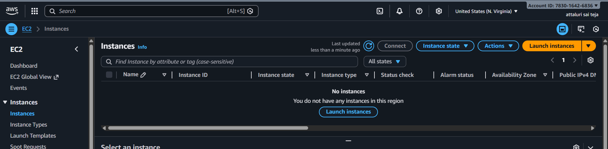
Select the configuration
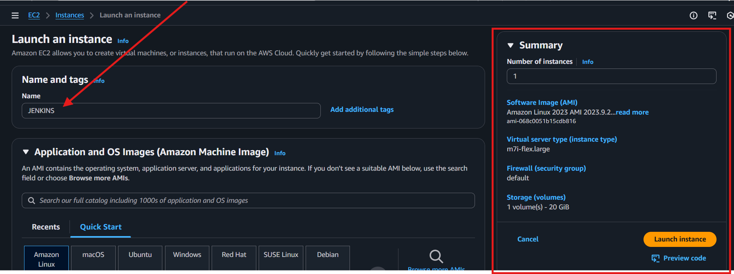
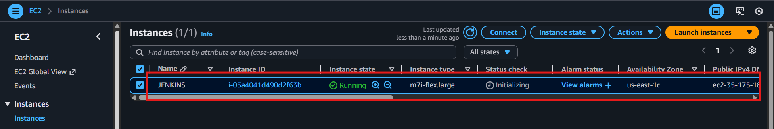
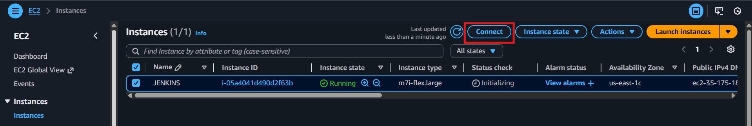
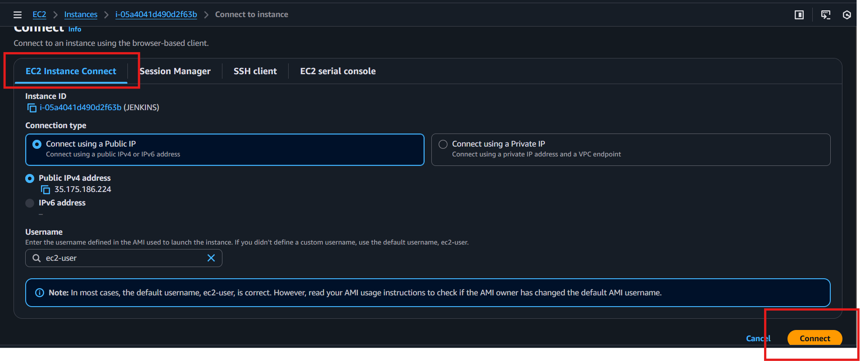
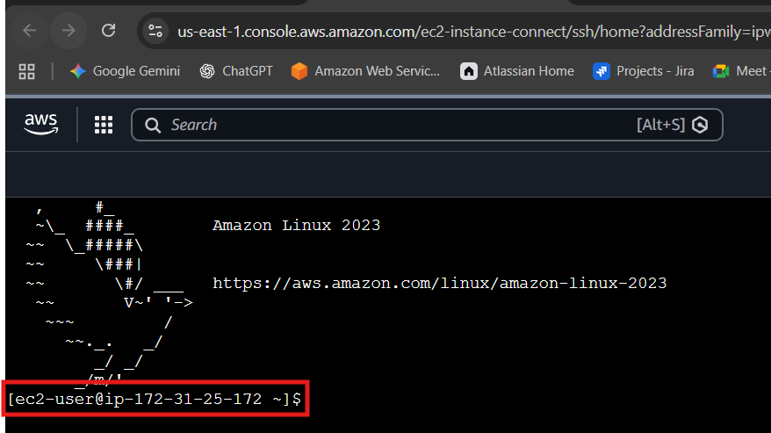
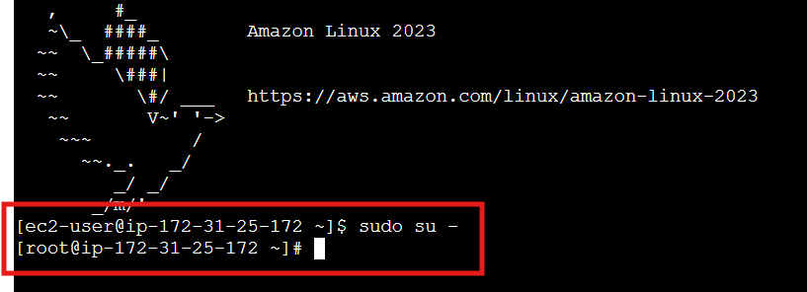
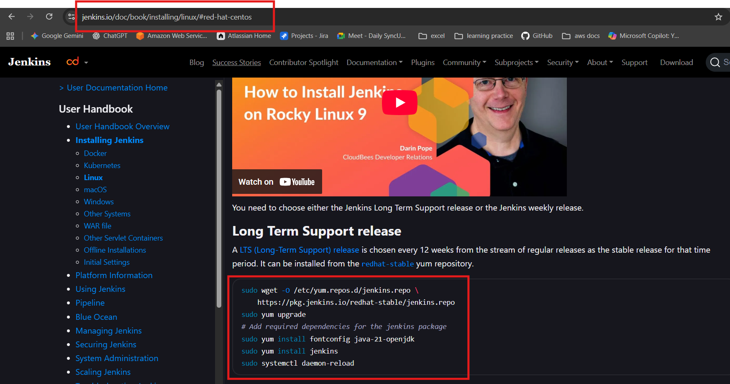
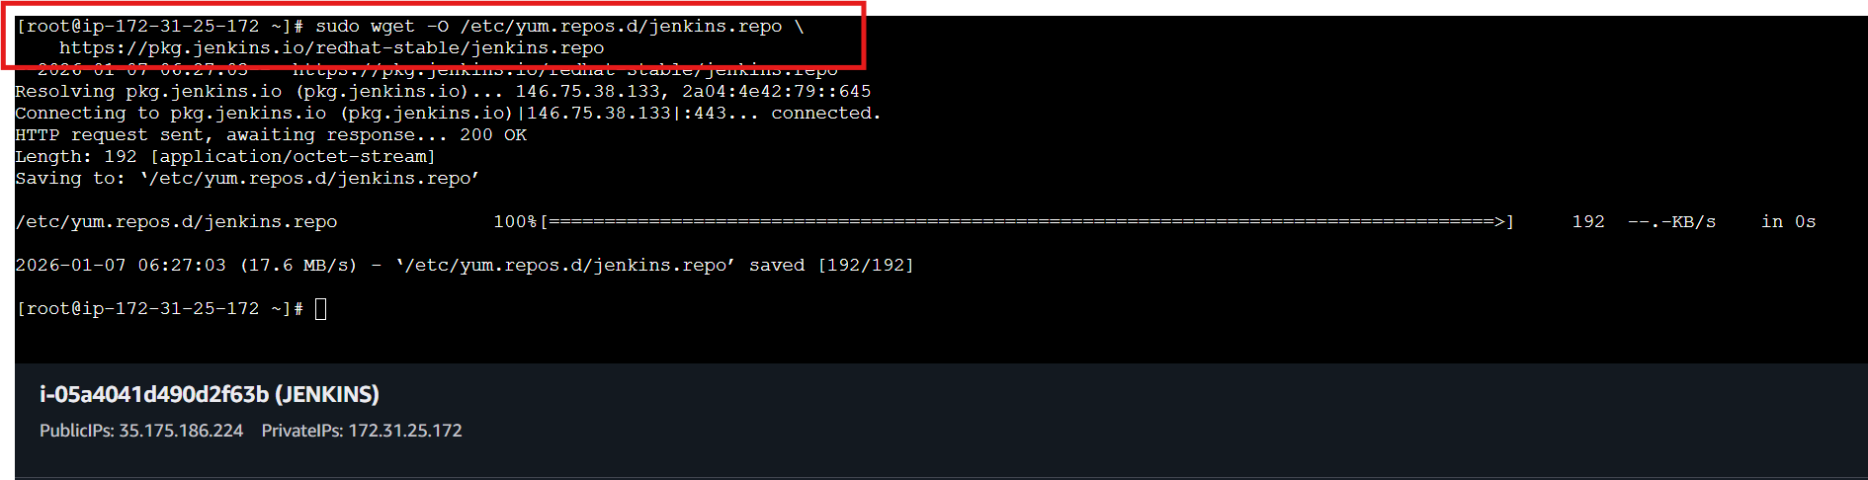
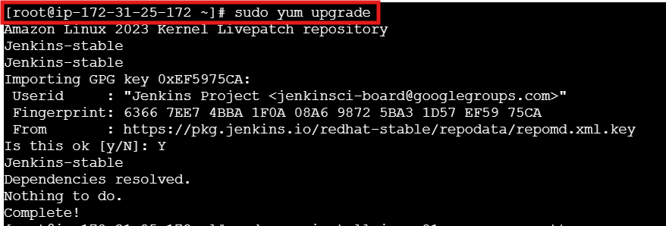
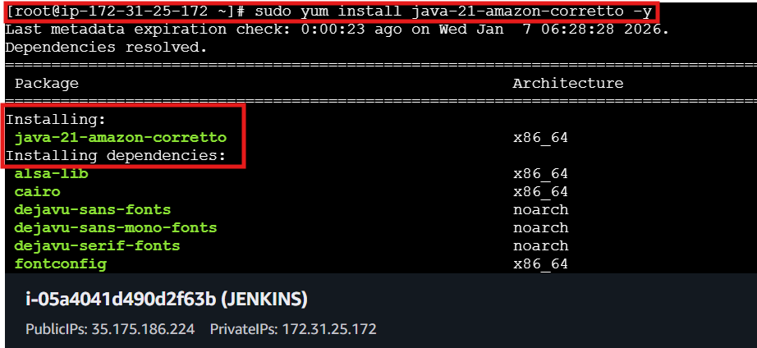
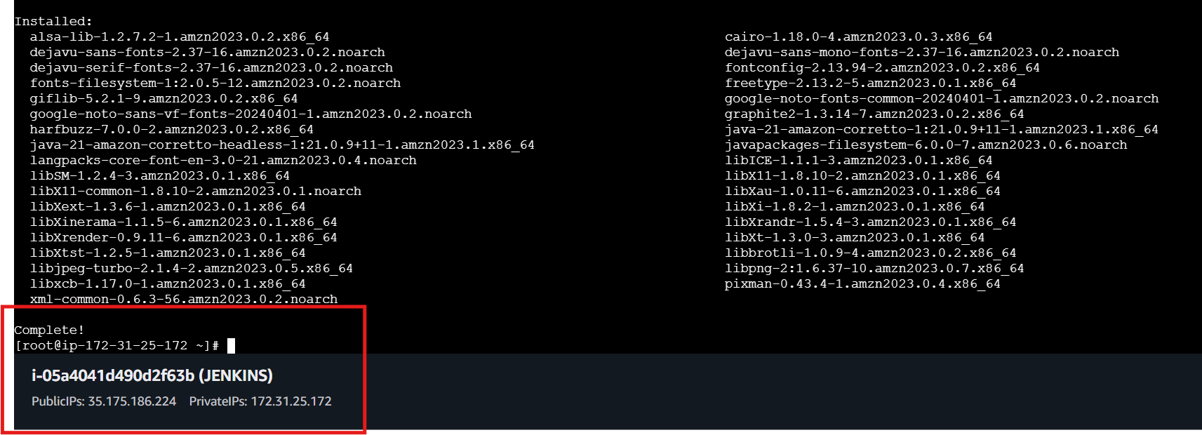
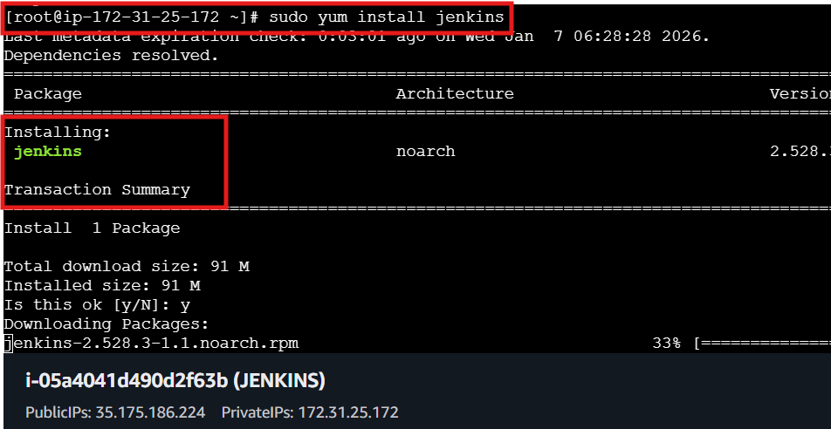
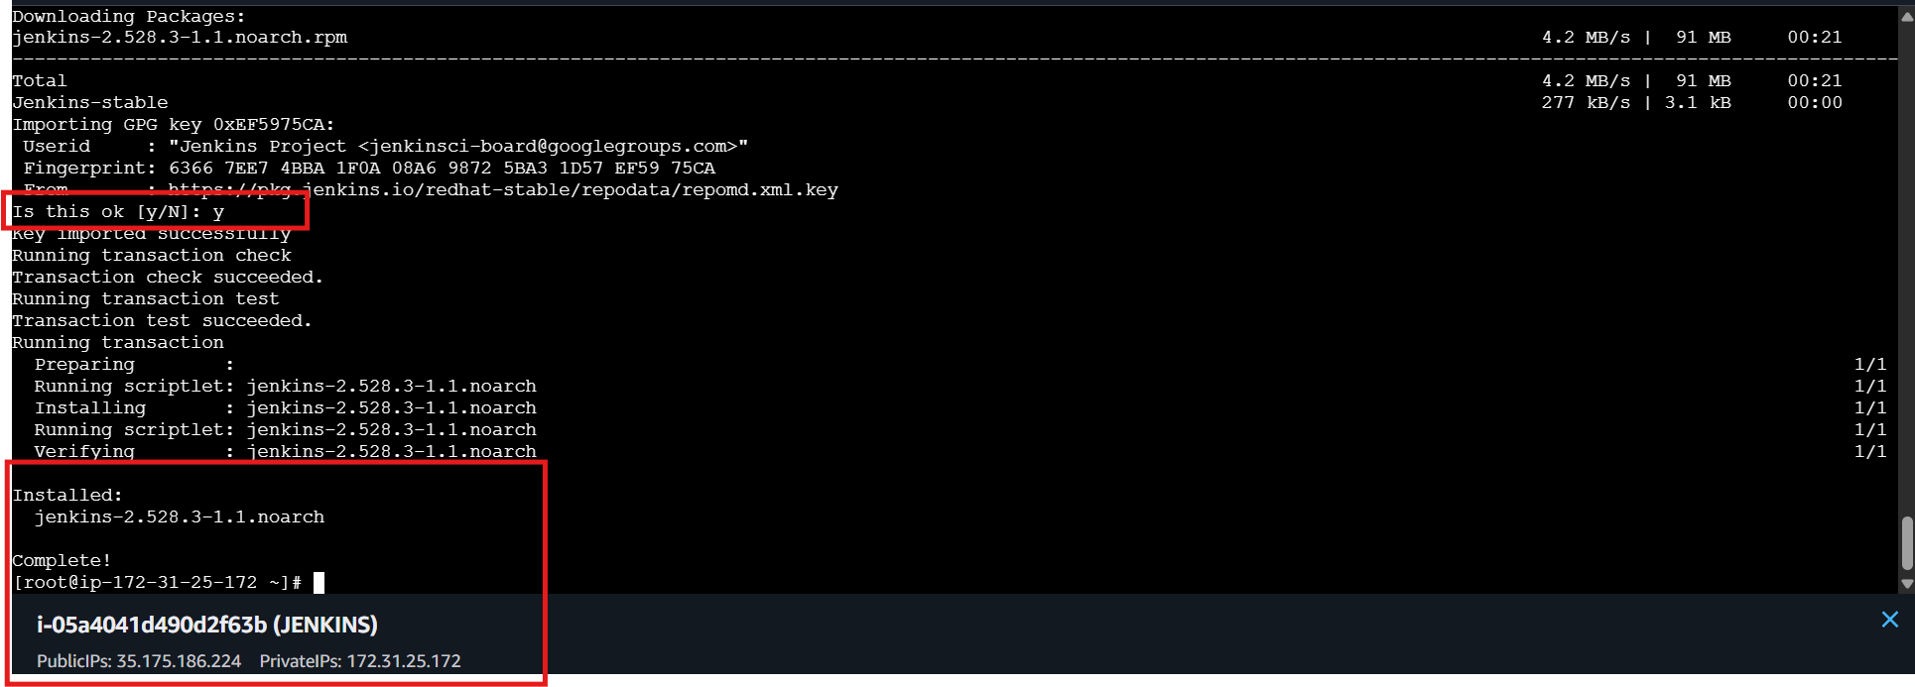
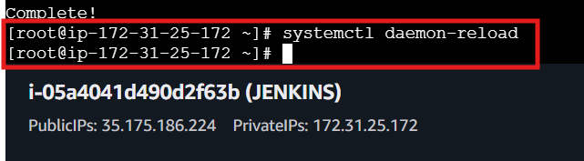
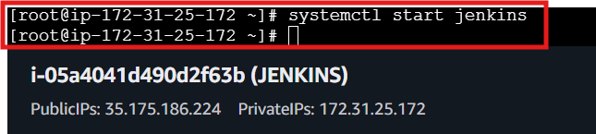
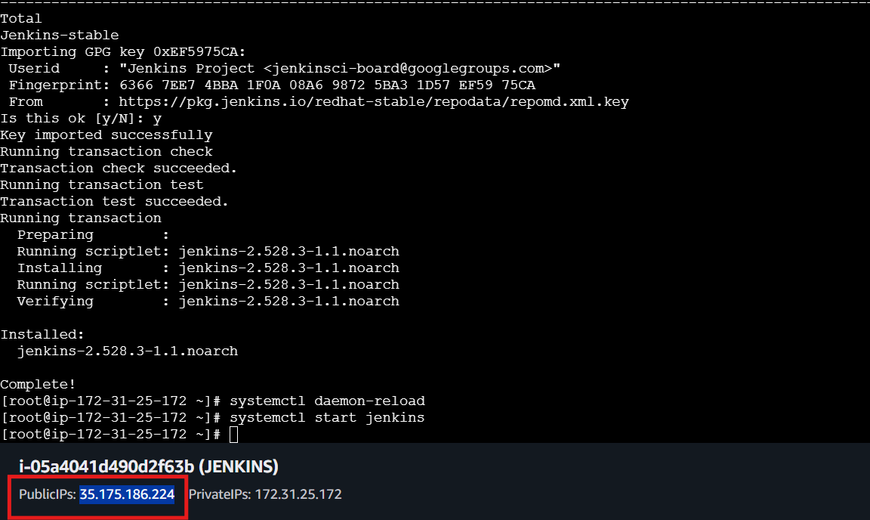
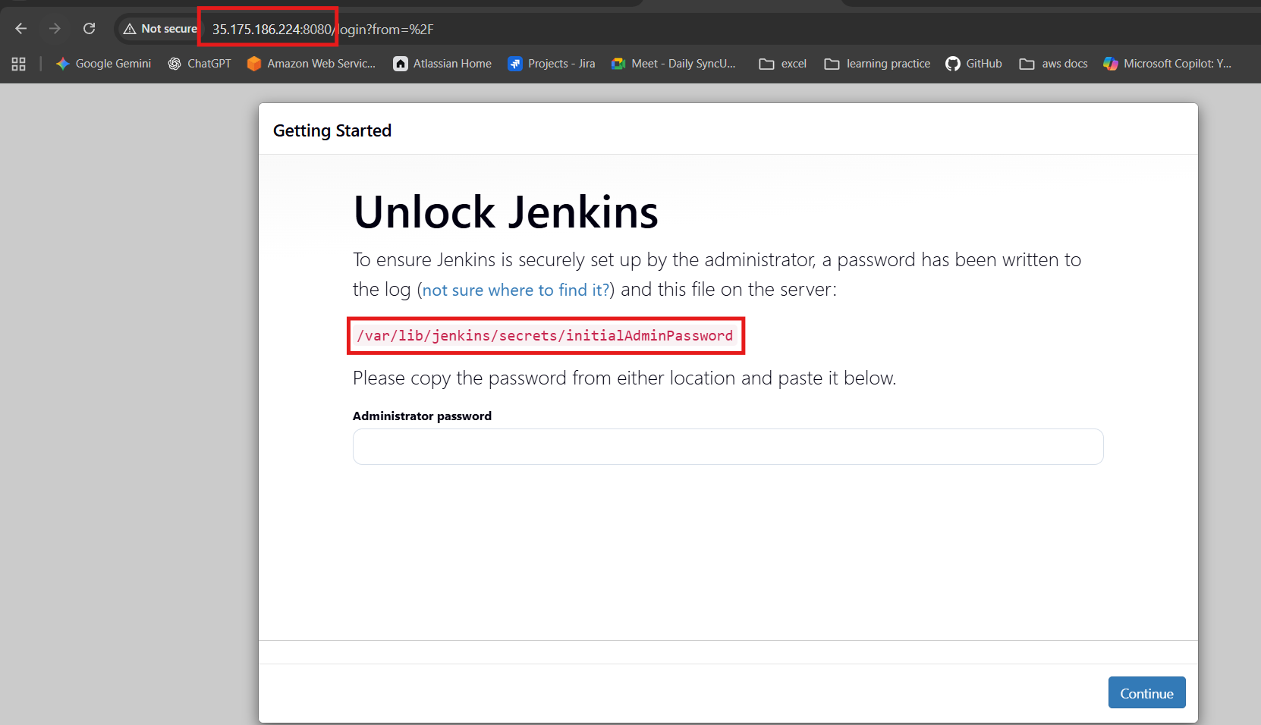
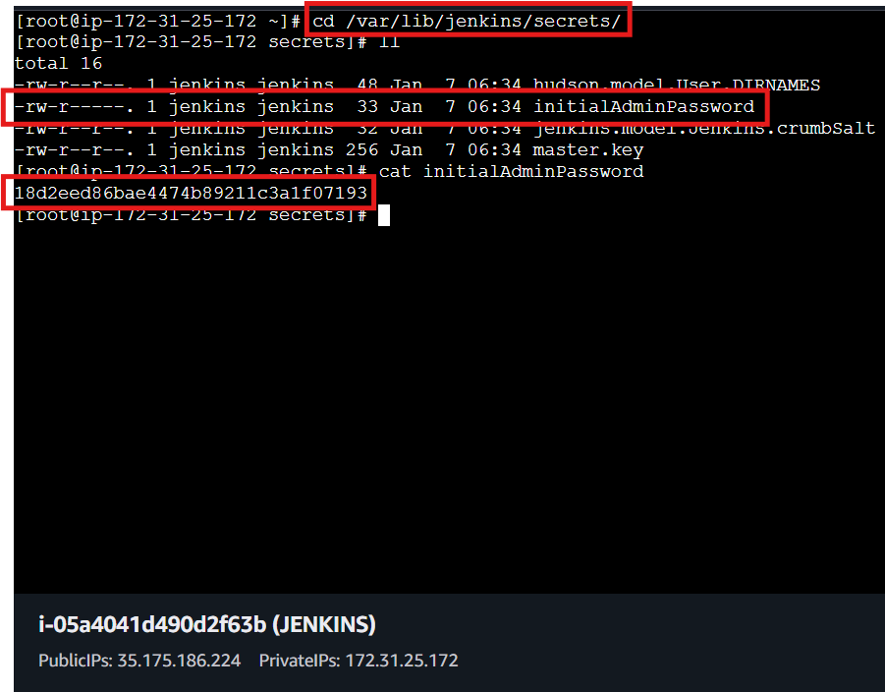
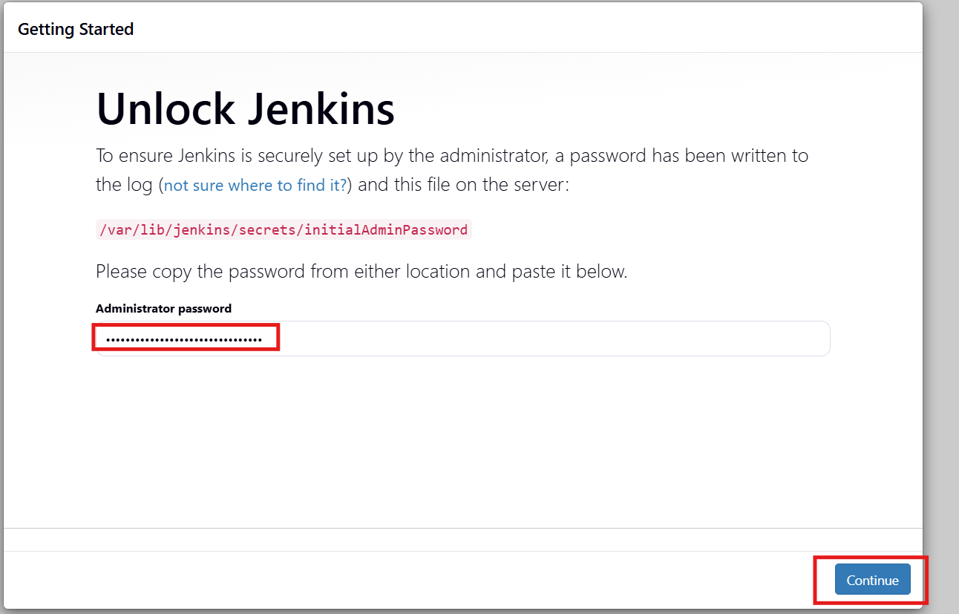
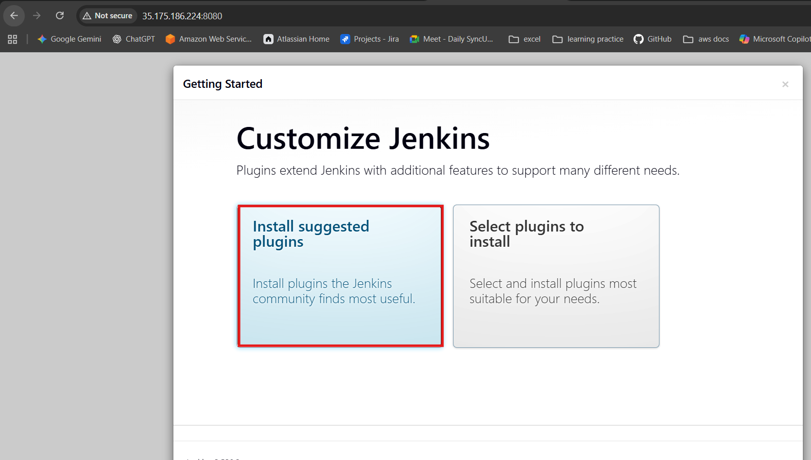
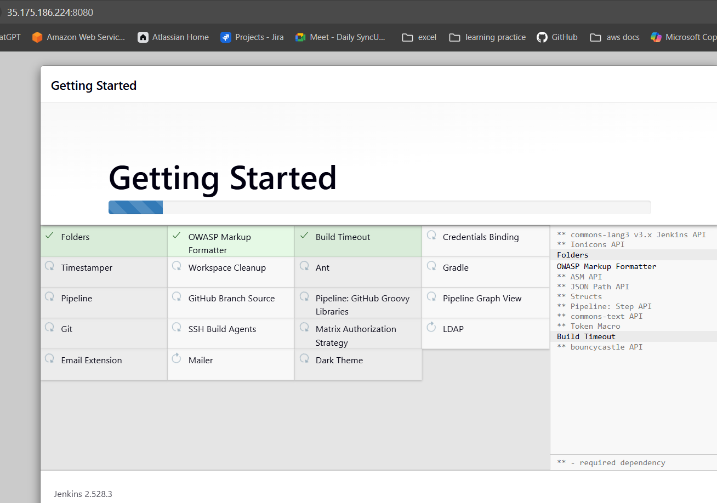
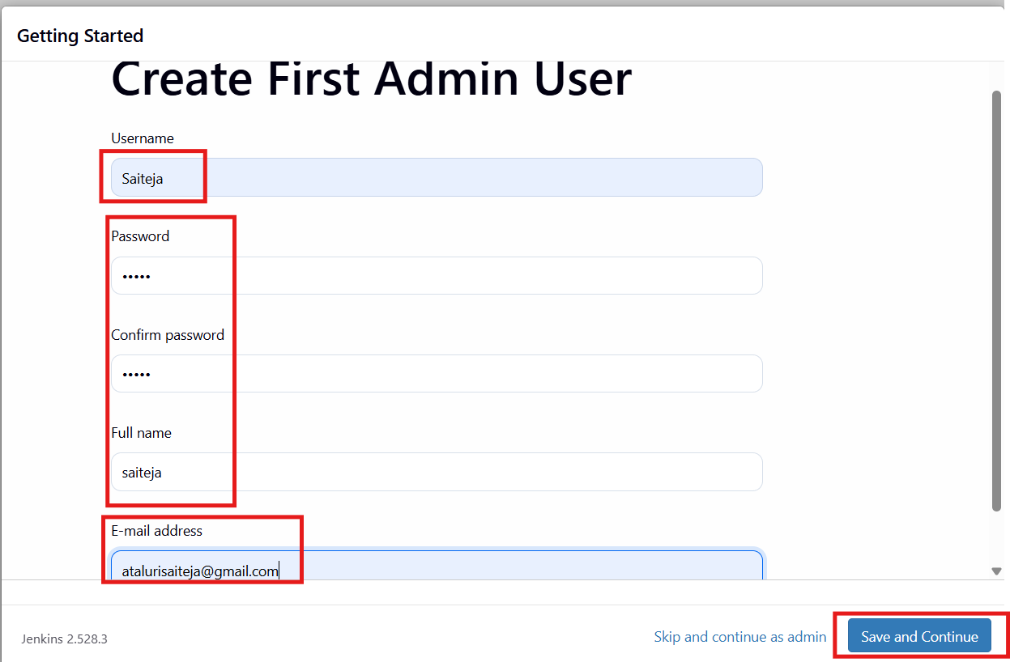
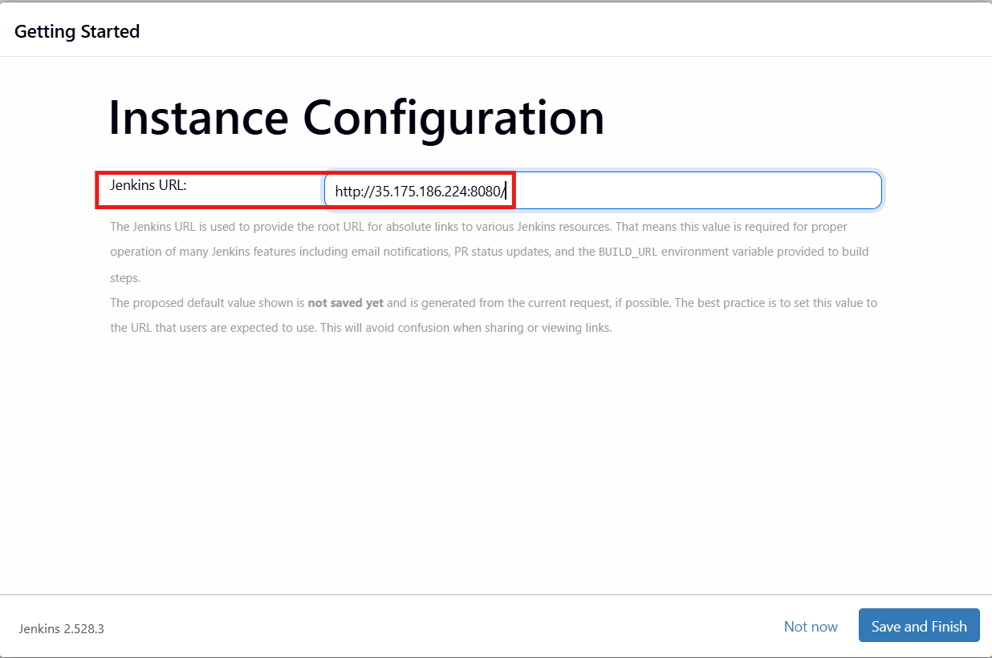
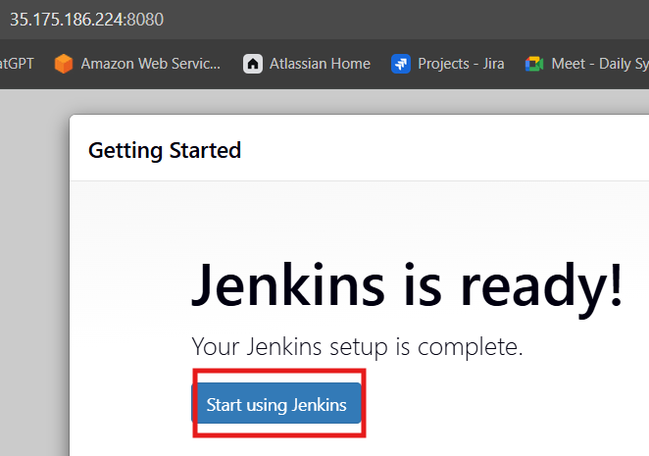
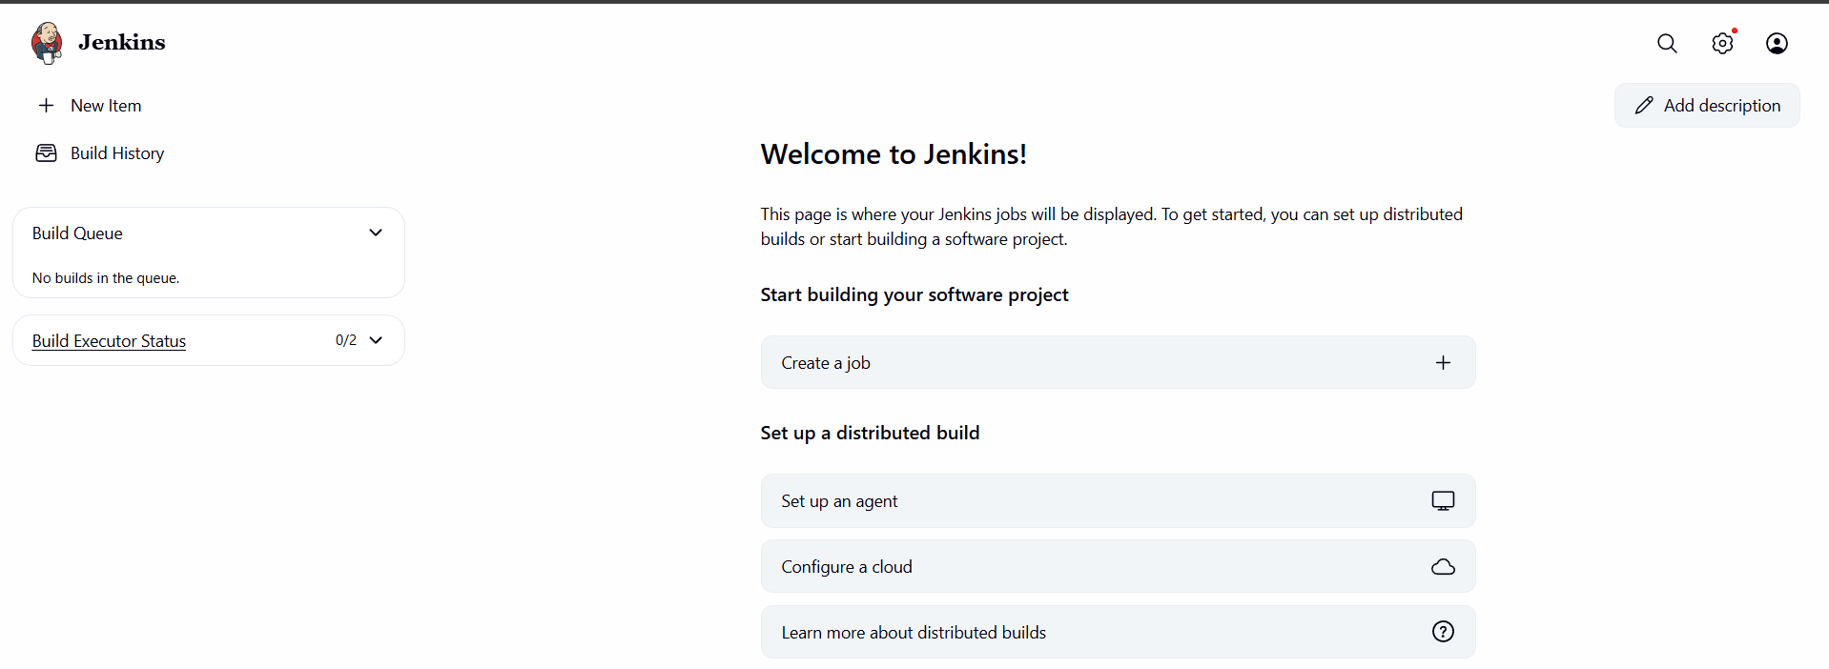
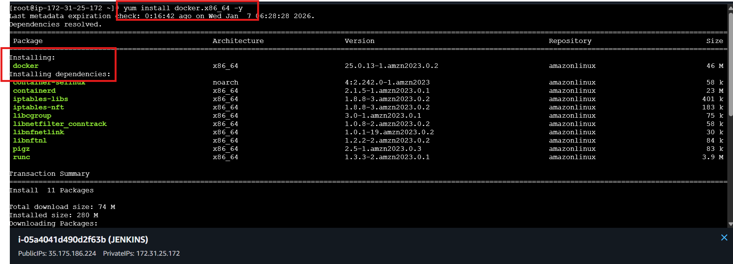
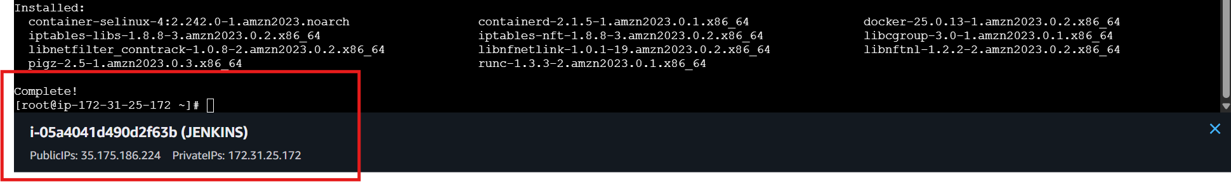
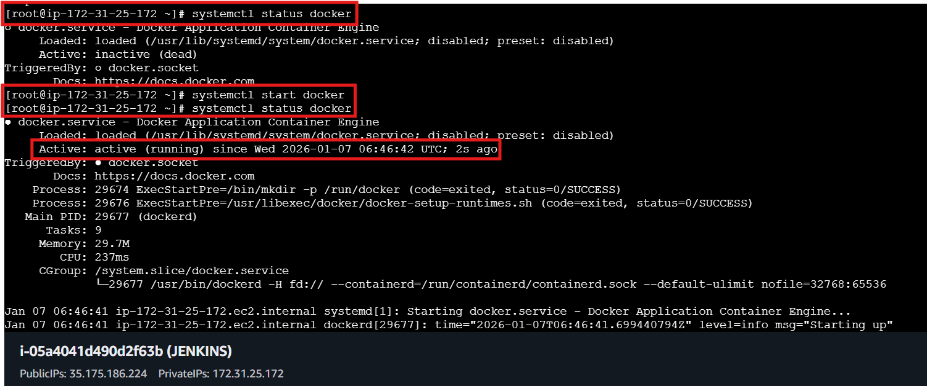
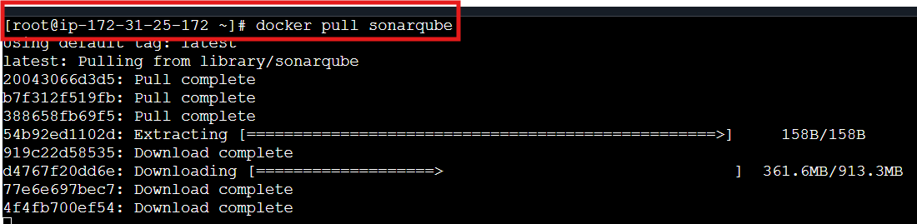
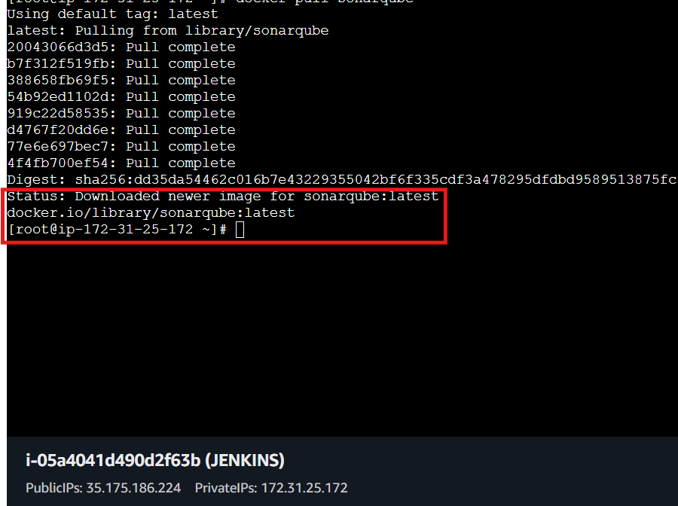
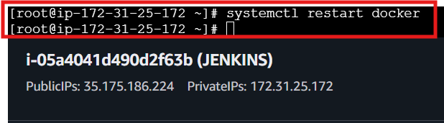
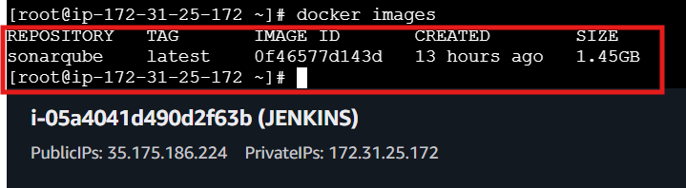
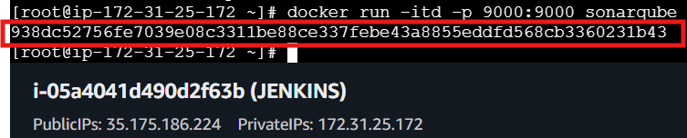
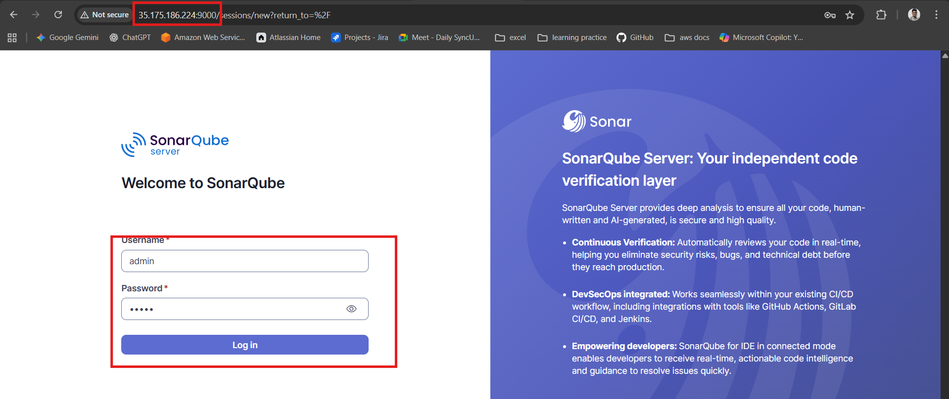
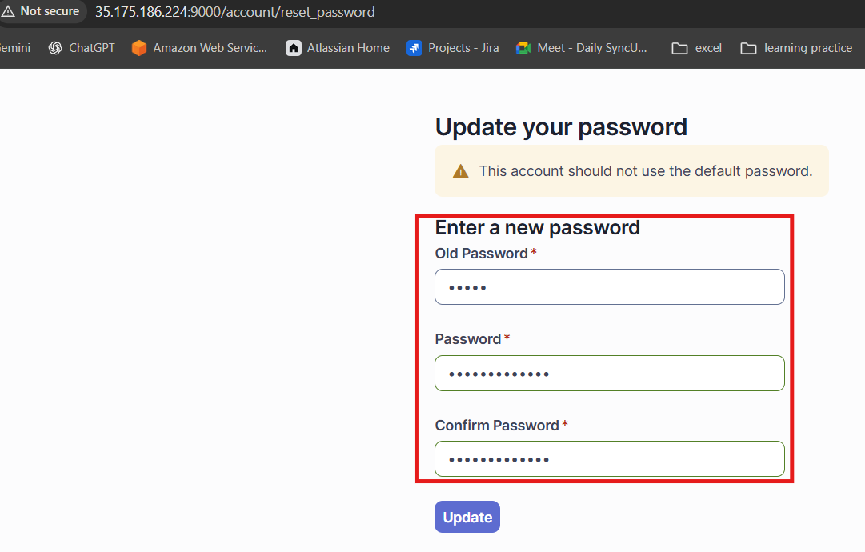
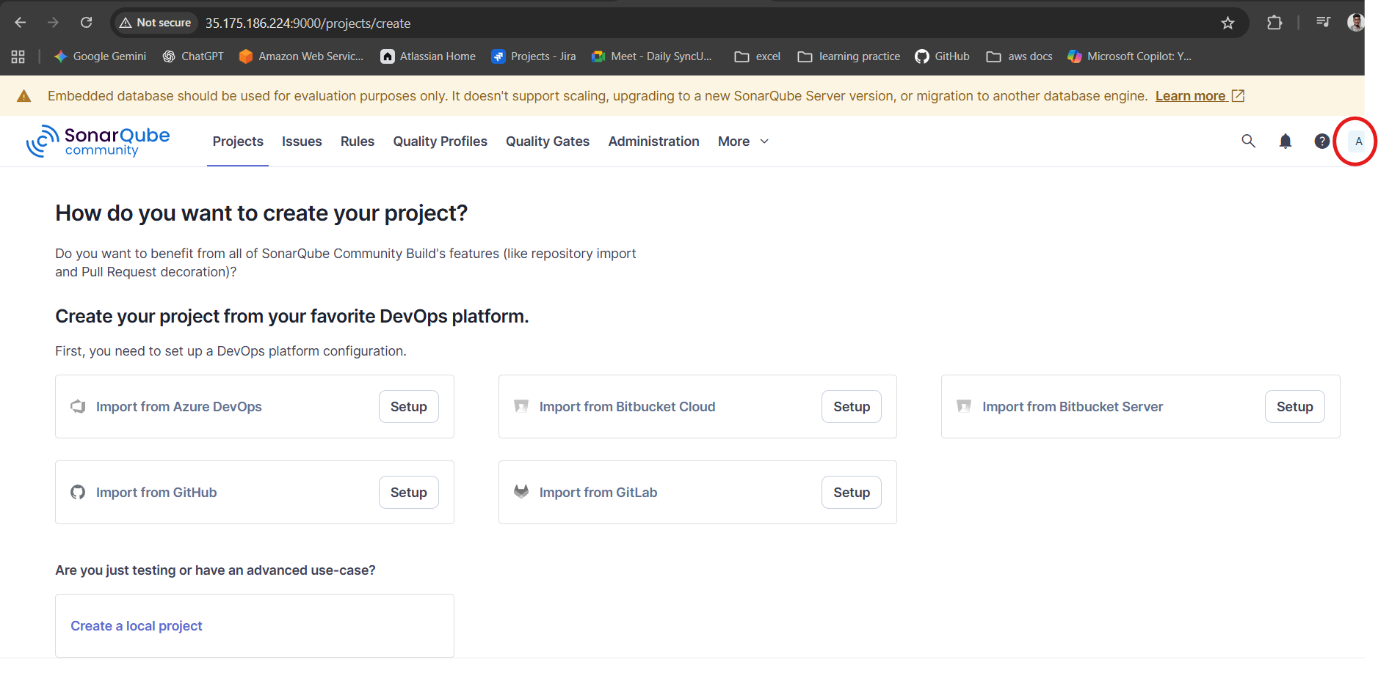

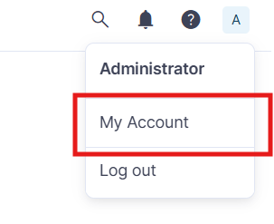
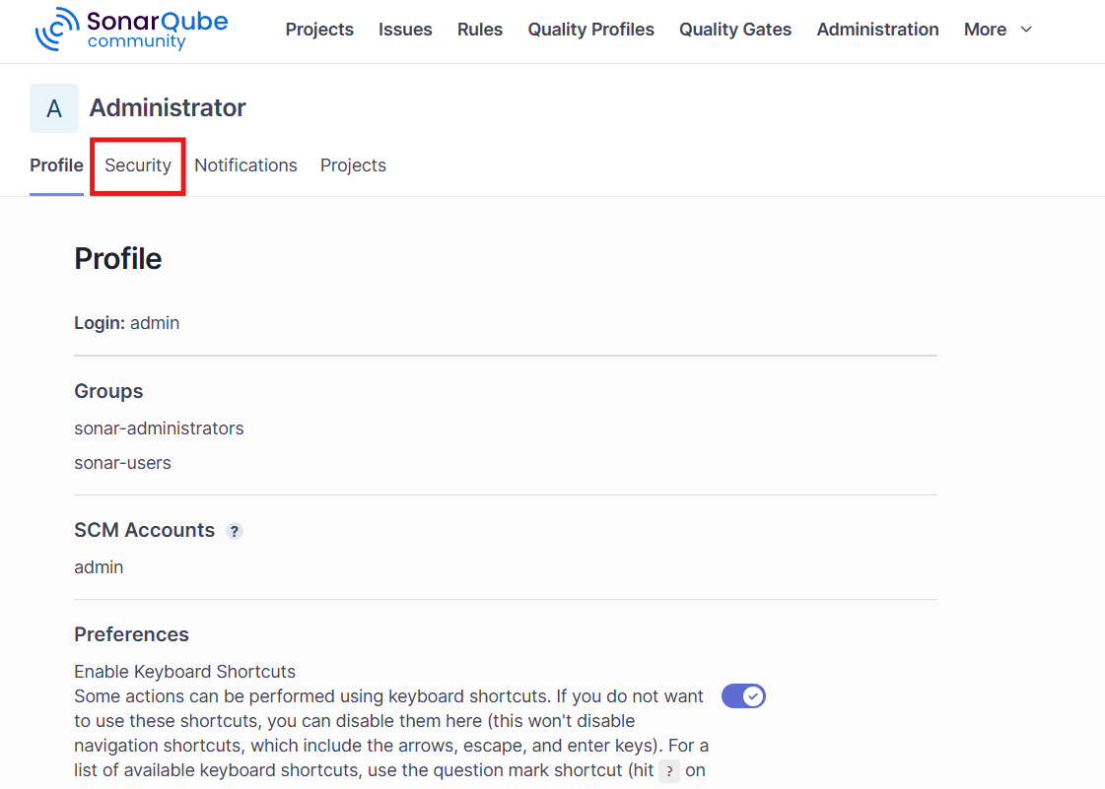
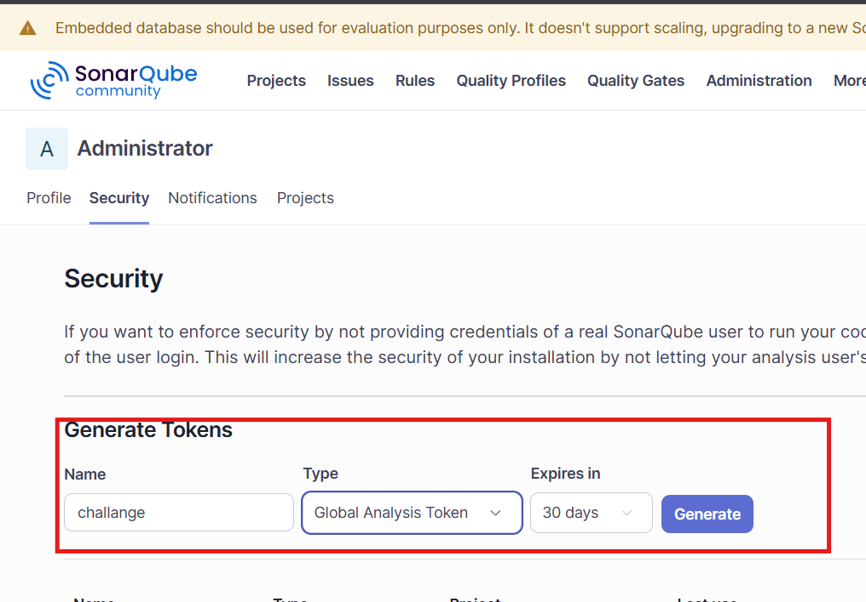
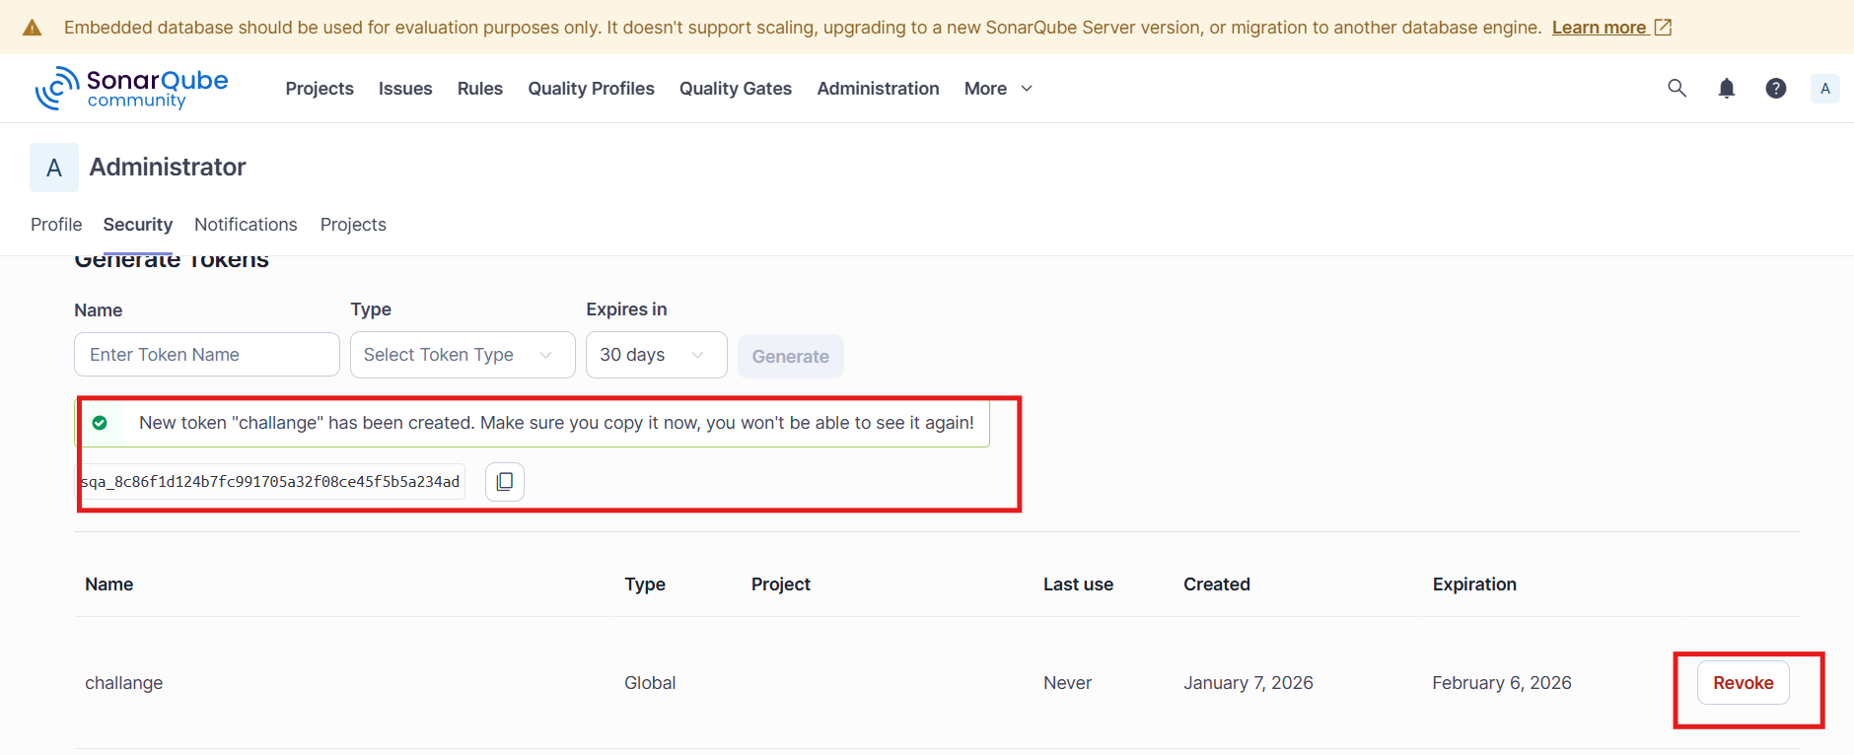
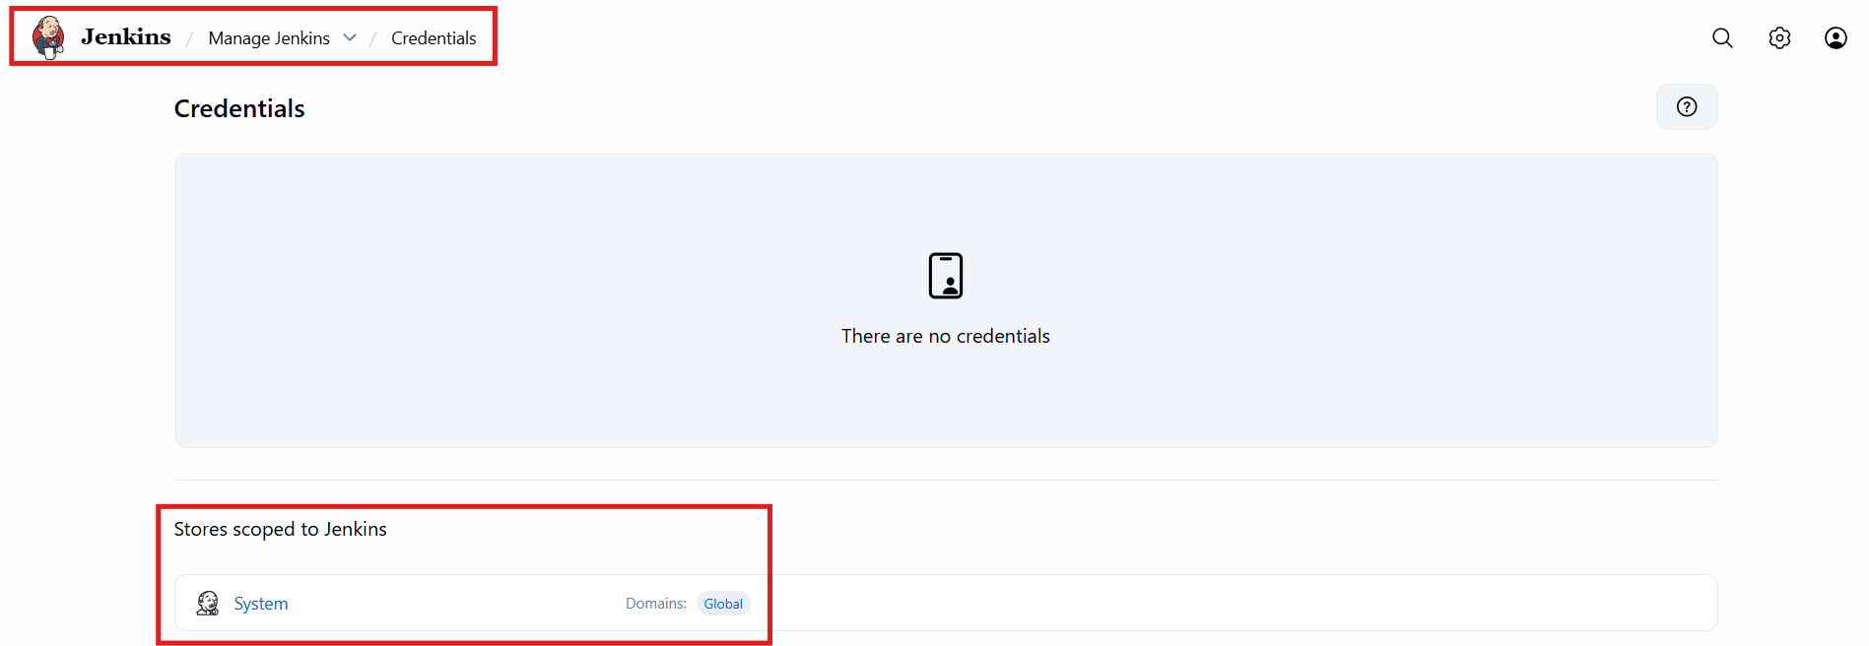
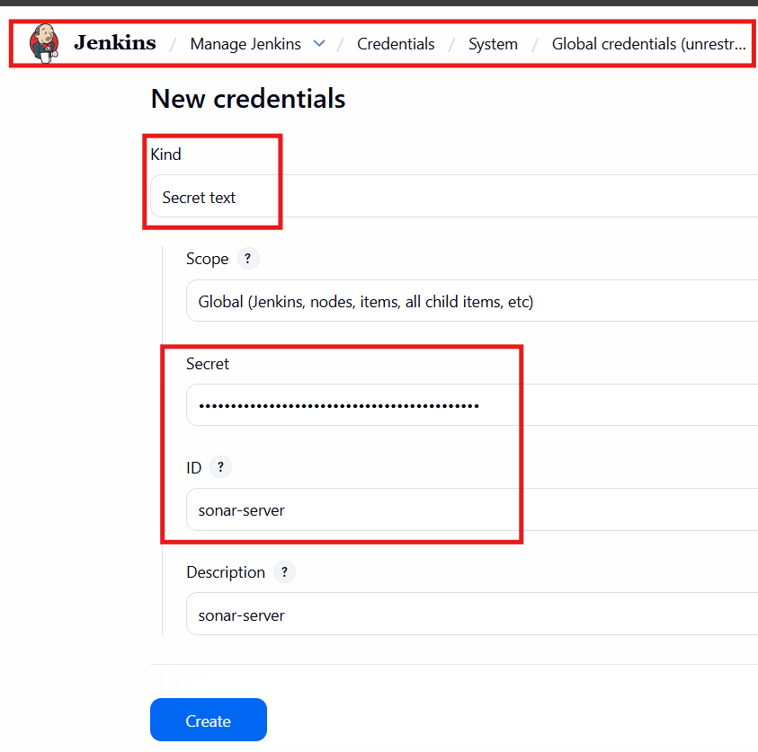
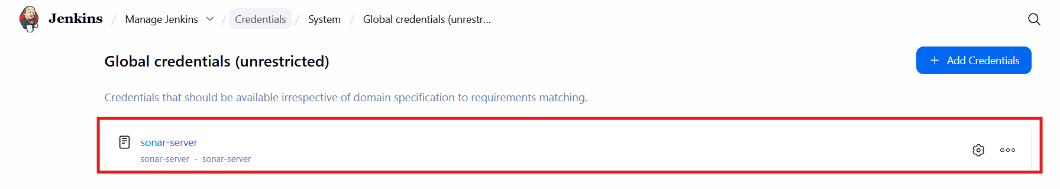
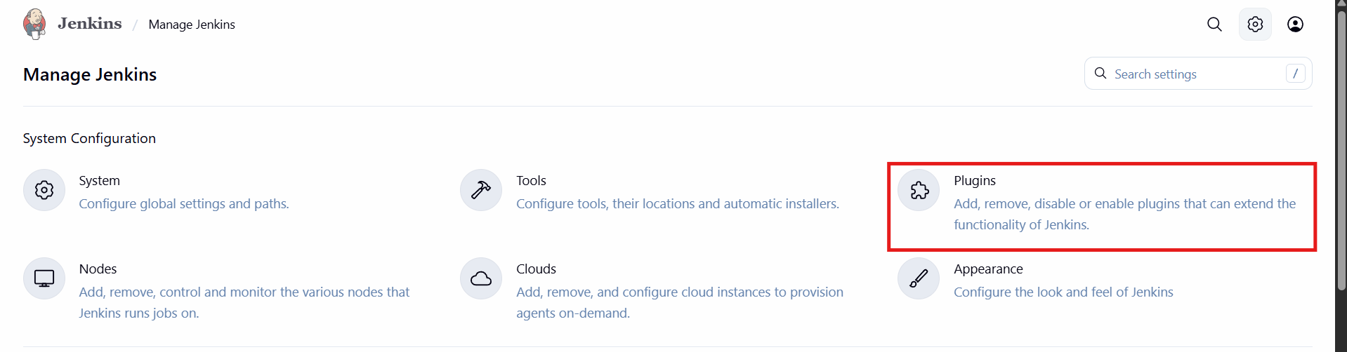
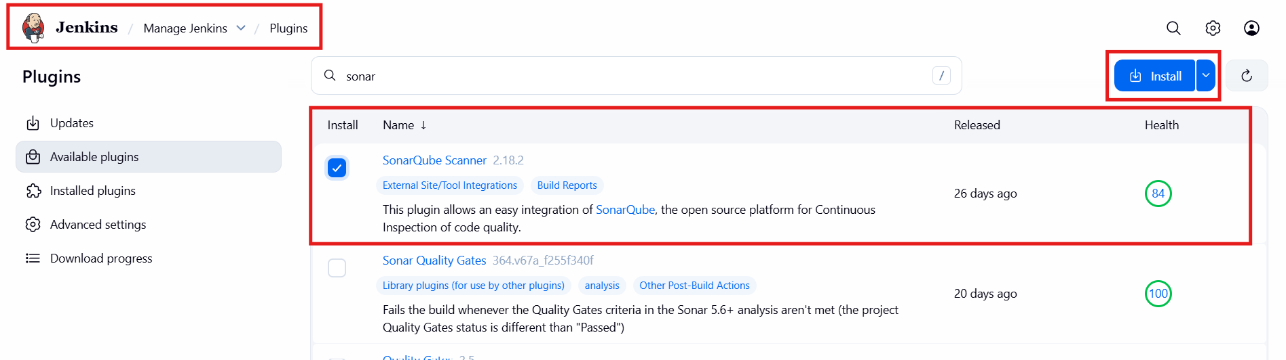
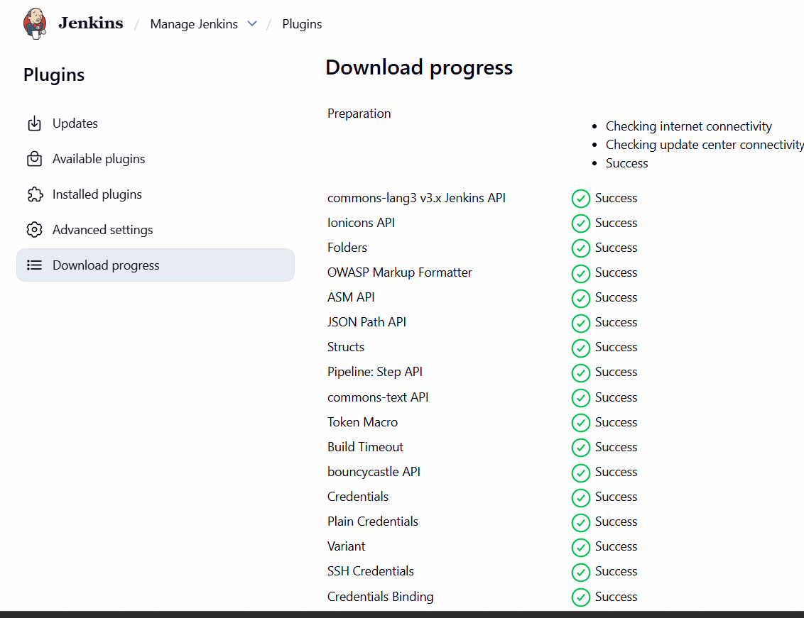

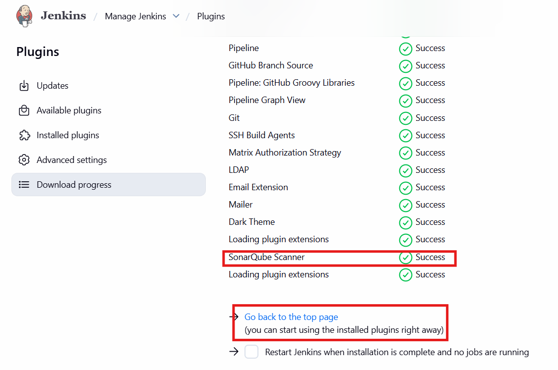
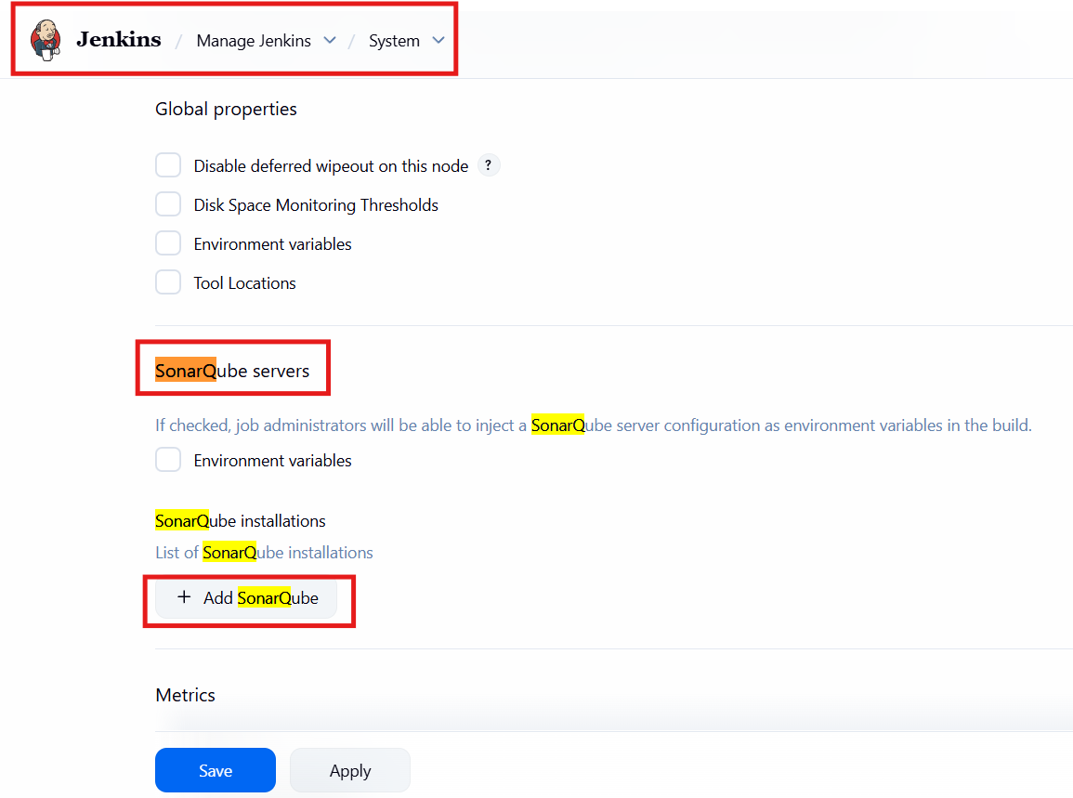
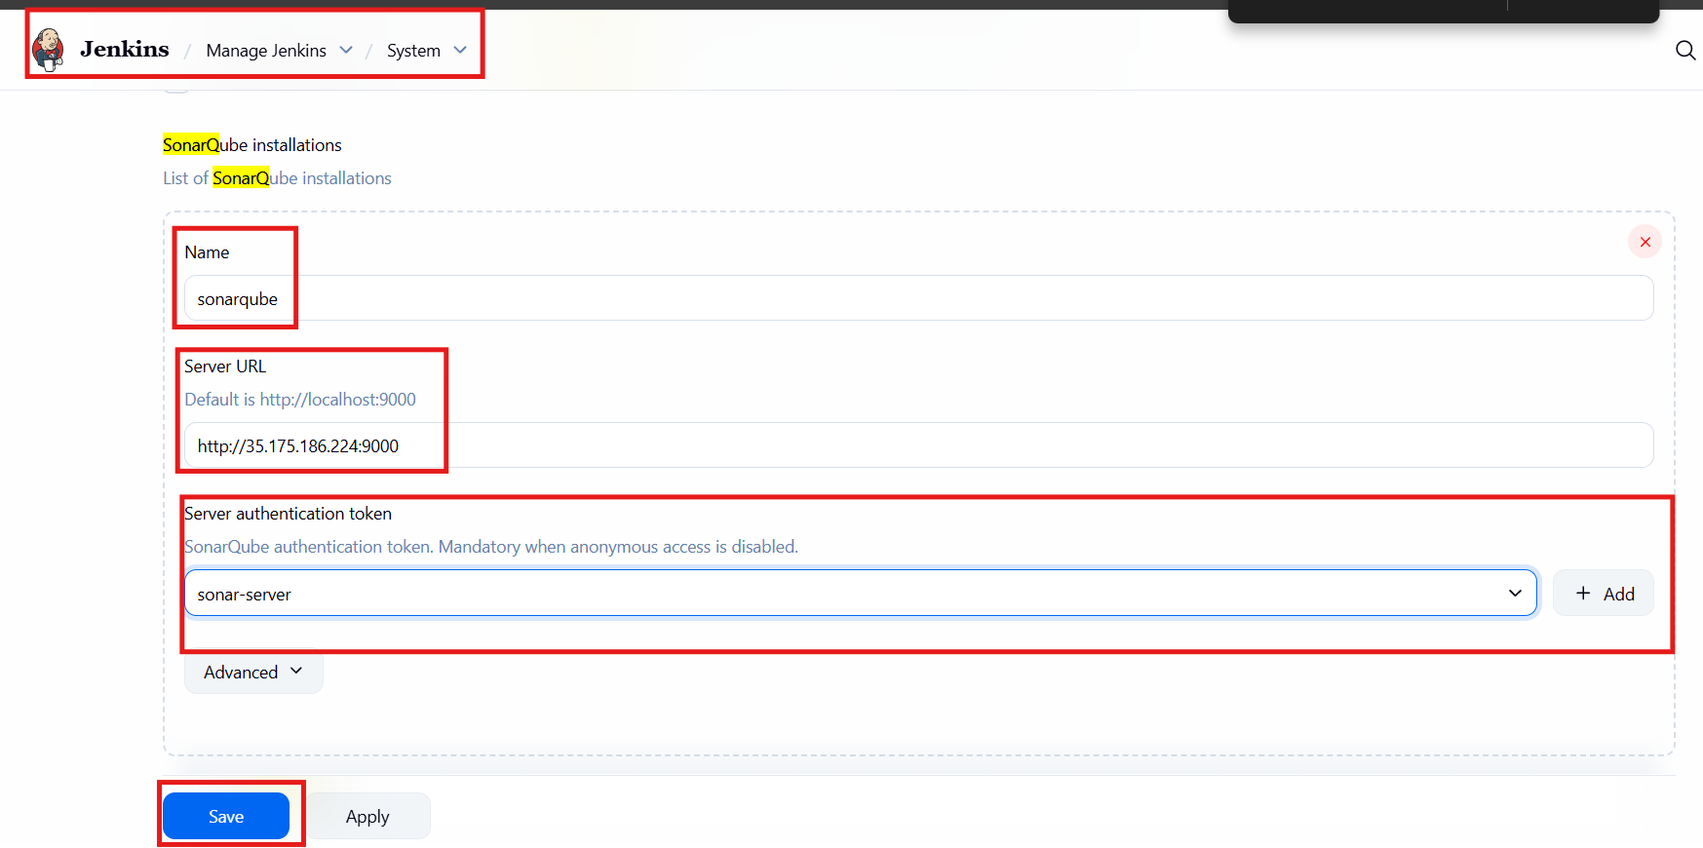
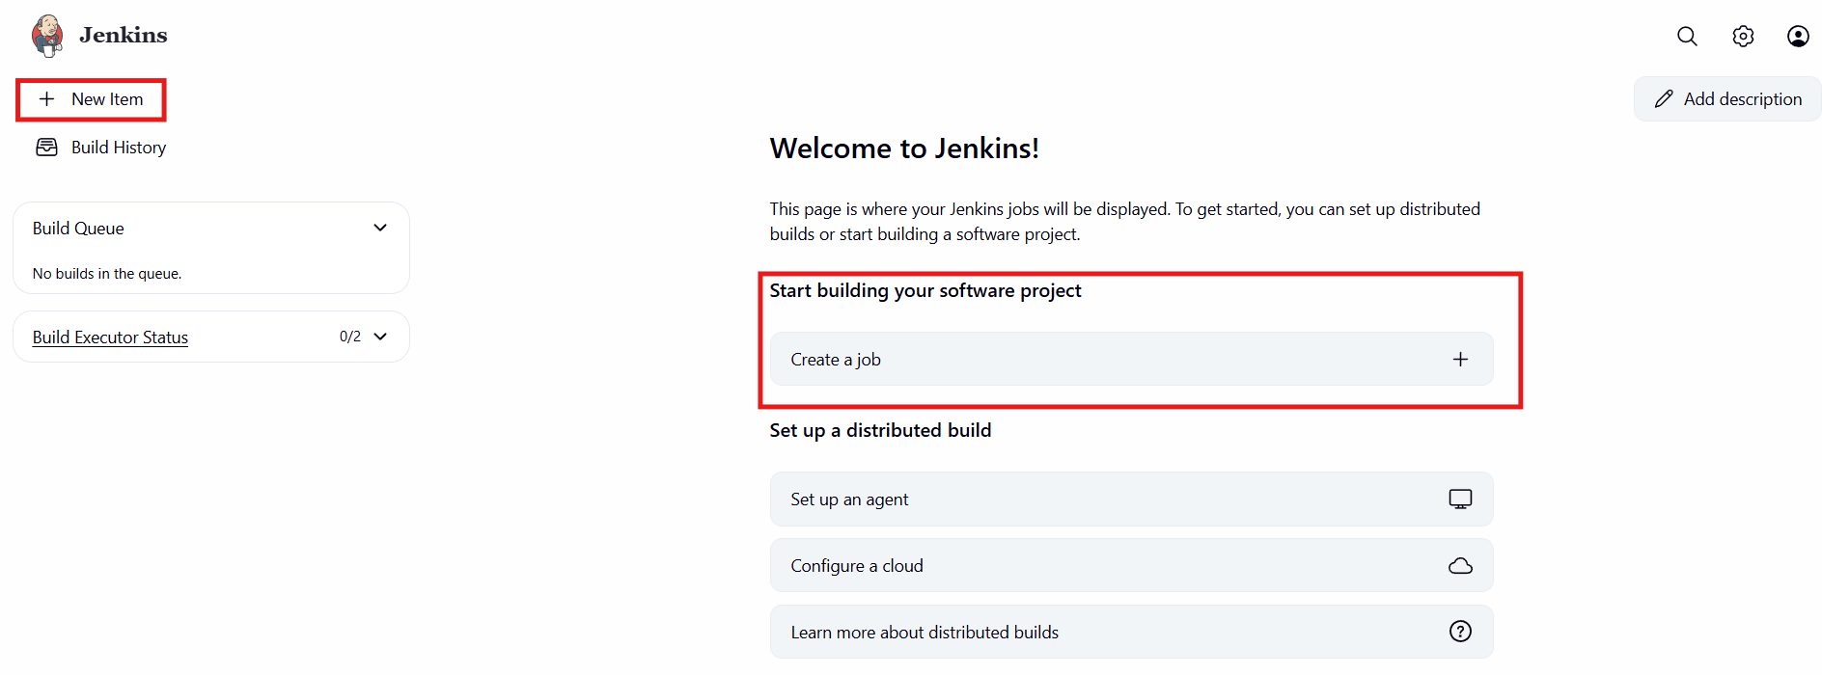
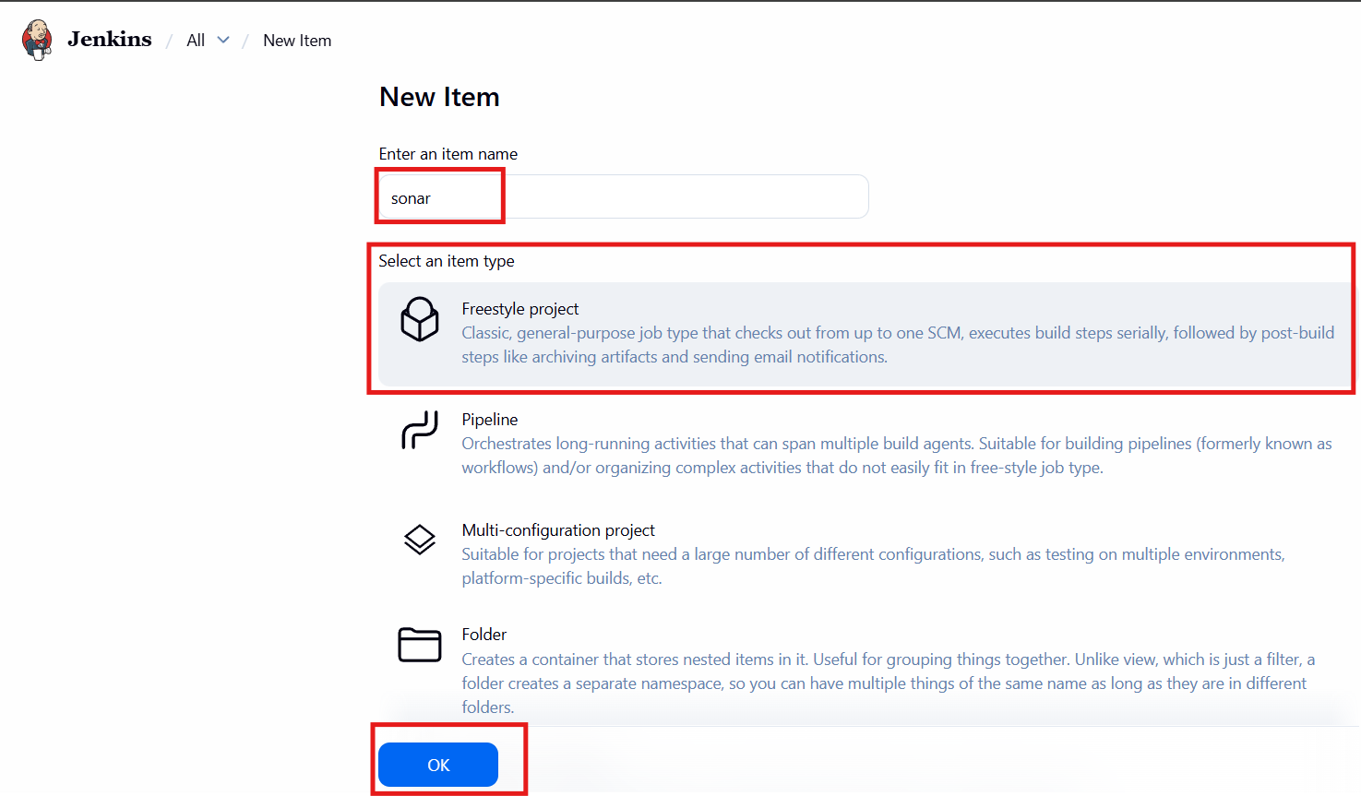
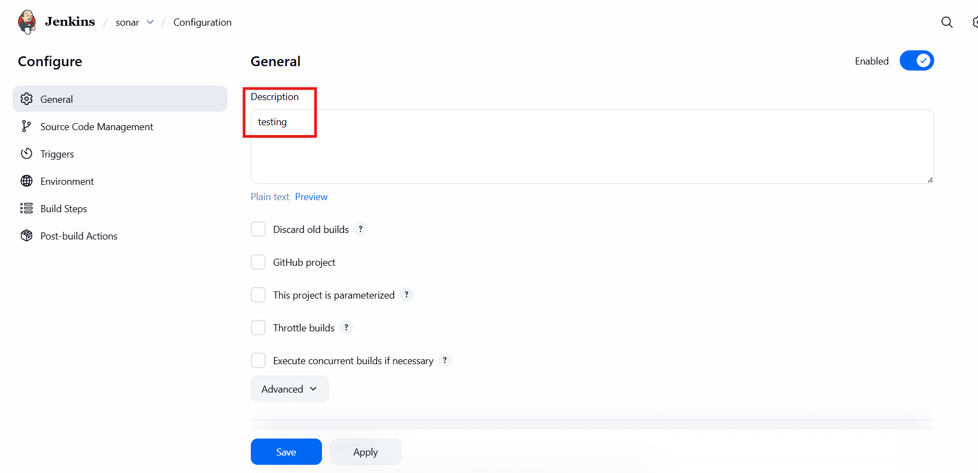
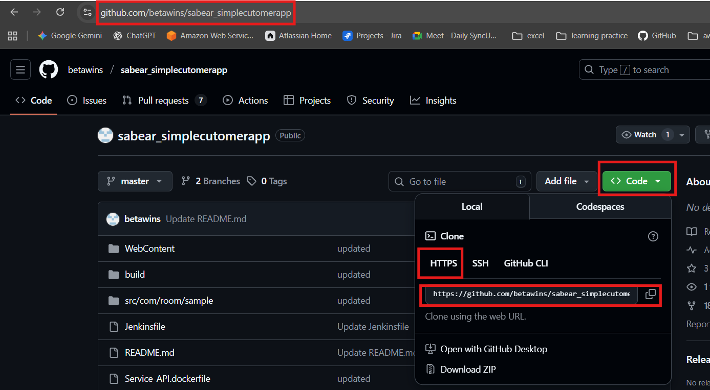
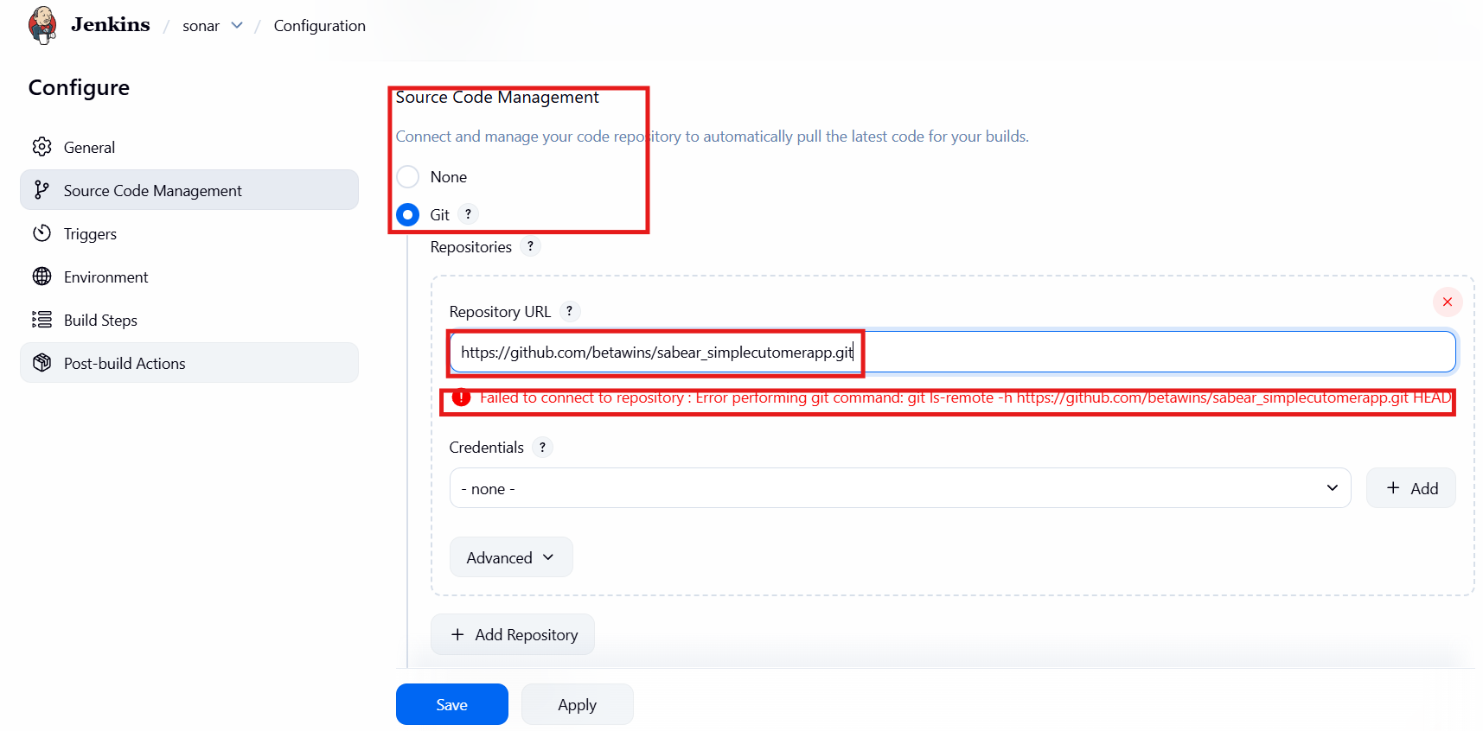
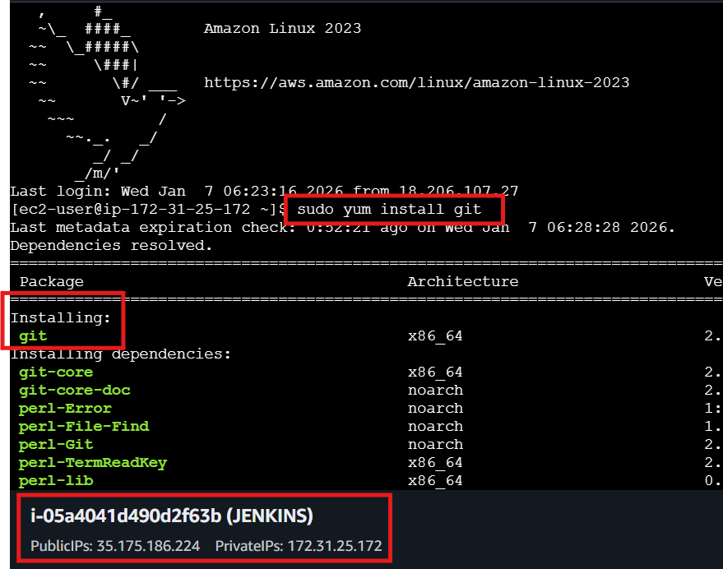
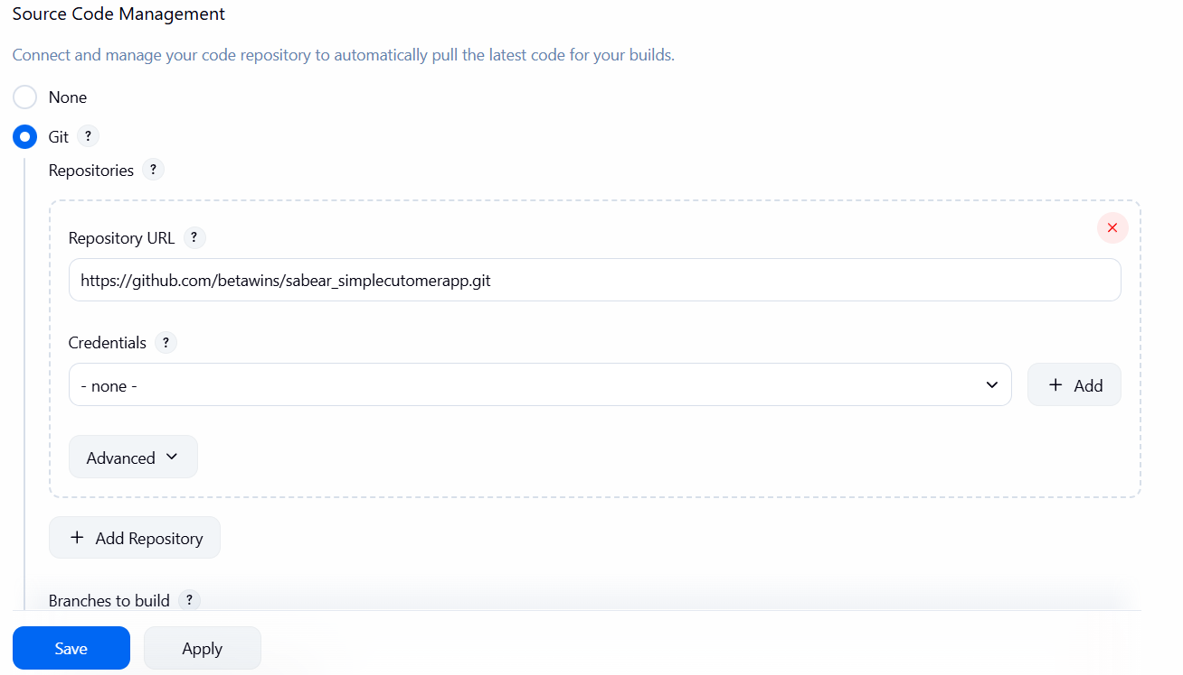
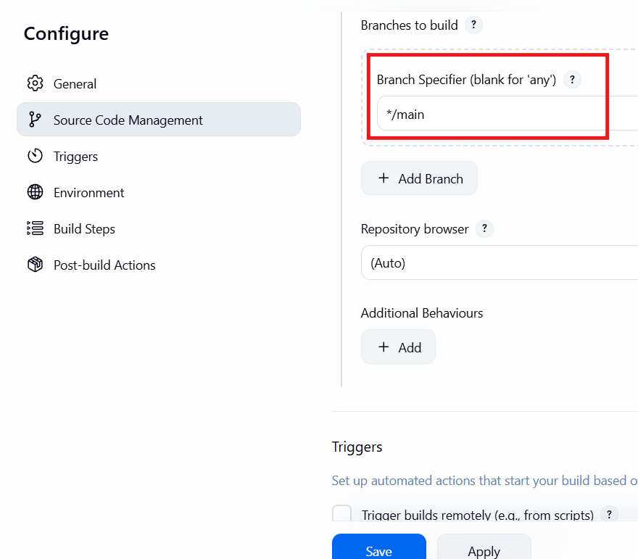
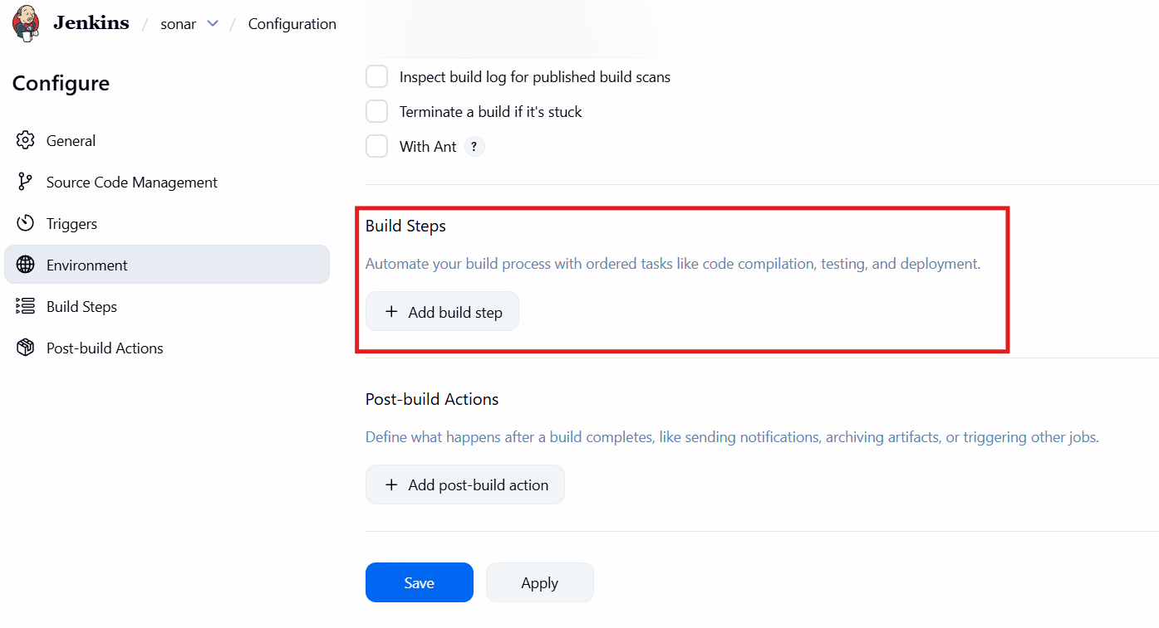
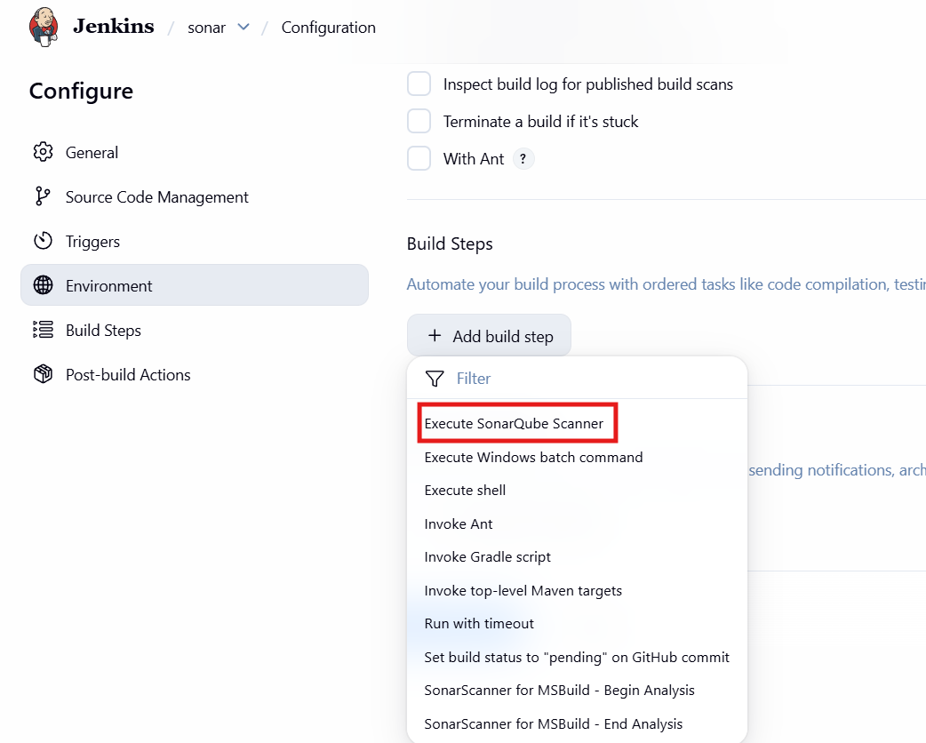
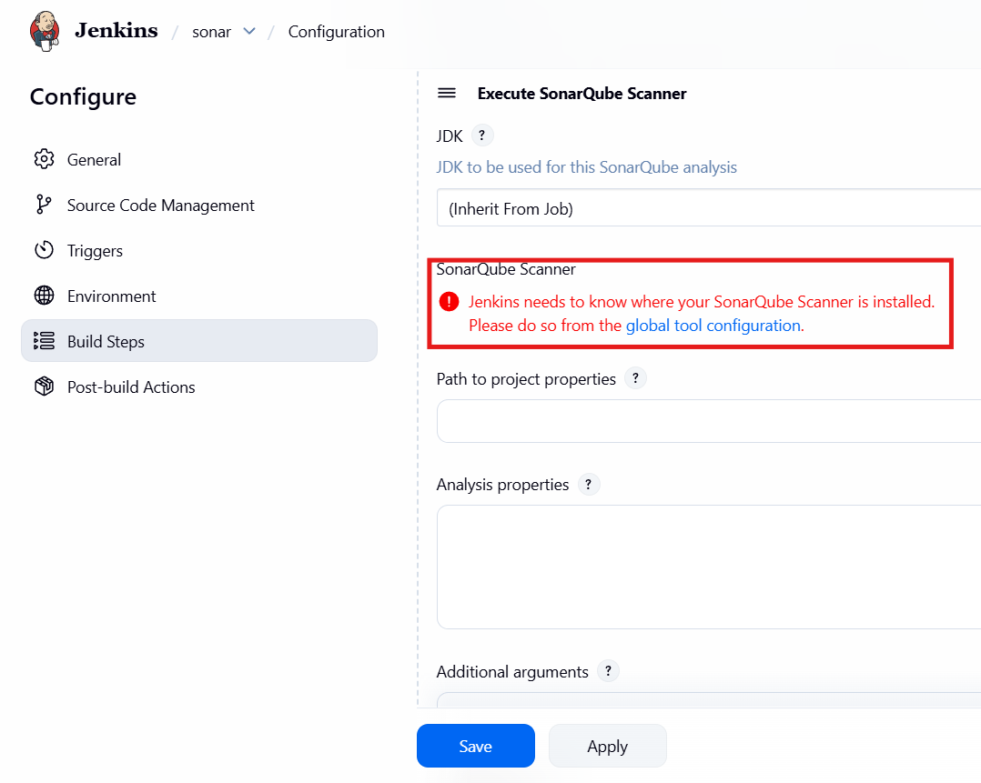
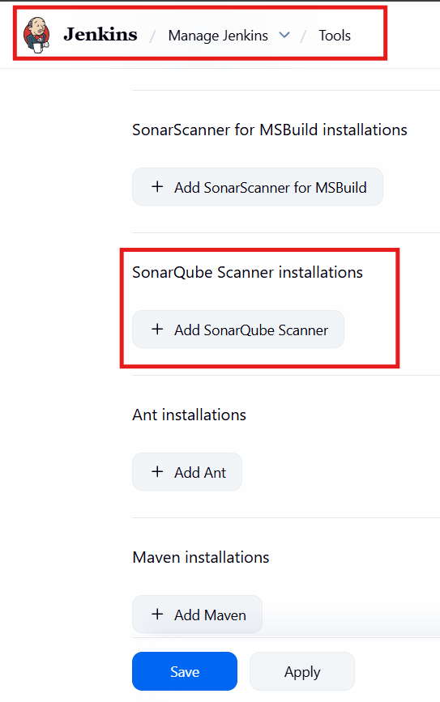
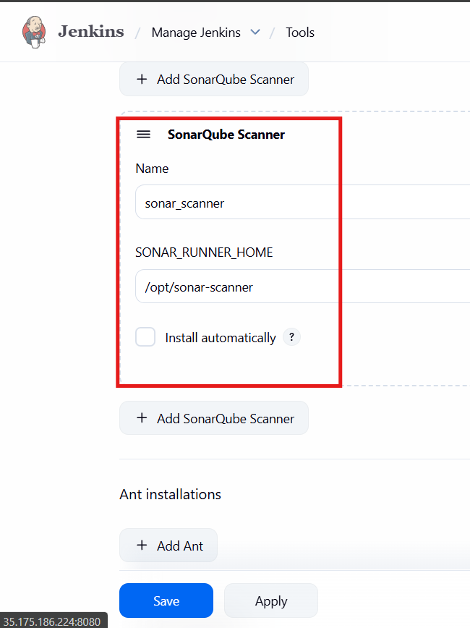
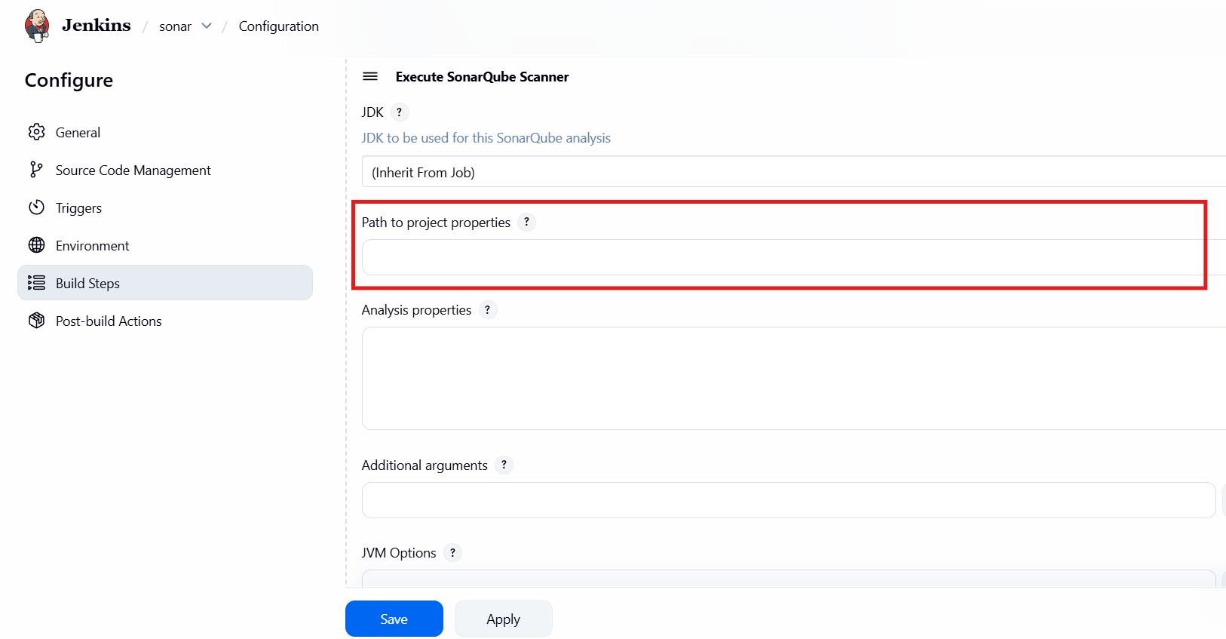
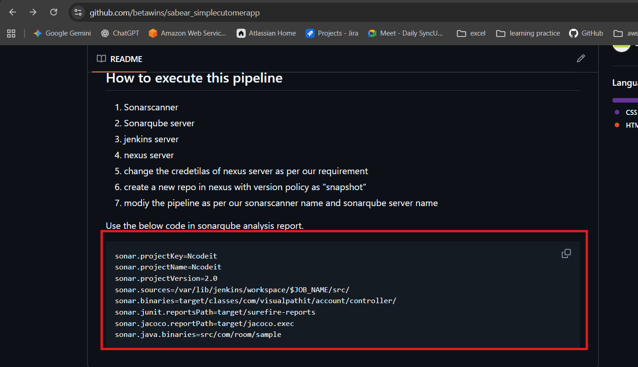
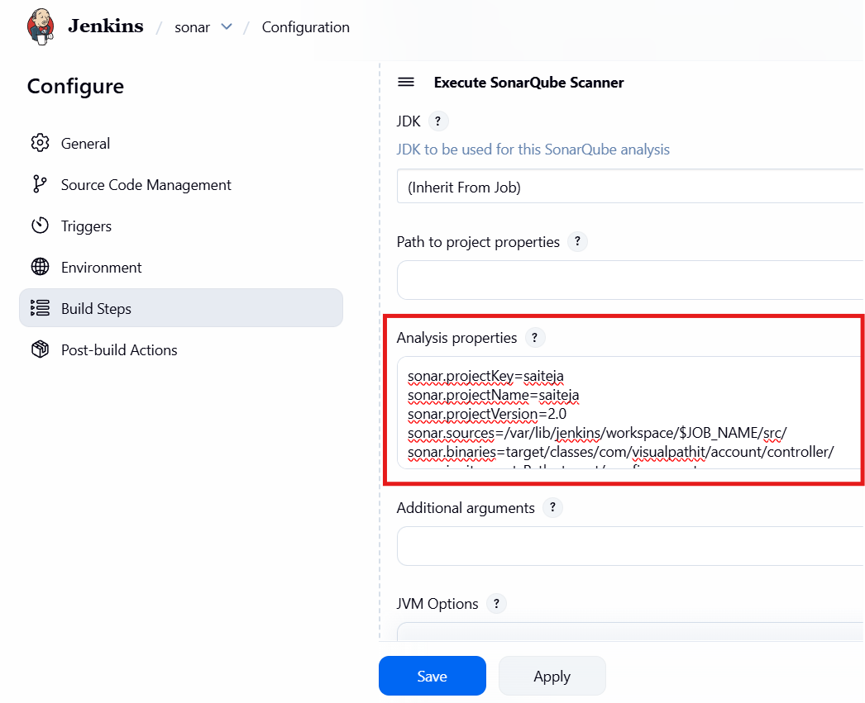
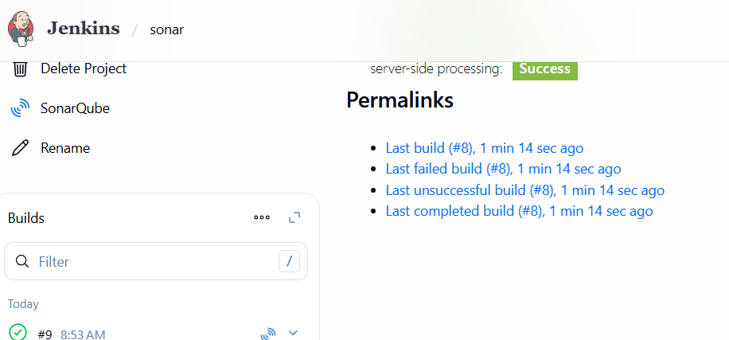

SonarScanner + Jenkins Error Resolution Checklist
1. Project Key / Unknown Error
- Error: You must define the following mandatory properties for 'Unknown': sonar.projectKey
- Fix:
  - Created sonar-project.properties in the Jenkins workspace.
  - Added mandatory properties:
properties
sonar.projectKey=Sabear
sonar.sources=src
sonar.java.binaries=target/classes
sonar.host.url=http://35.175.186.224:9000
sonar.token=<valid_token>
  - Ensured the file was in /var/lib/jenkins/workspace/sonar.

2. Token / Authorization Error
- Error: Not authorized. Please check the user token in the property 'sonar.token' or 'sonar.login' (deprecated).
- Fix:
  - Generated a new token in SonarQube (My Account → Security → Generate Tokens).
  - Replaced sonar.login with sonar.token (since sonar.login is deprecated).
  - Updated sonar-project.properties with the new token.

3. Missing Source Folder Error
- Error: The folder 'src' does not exist for 'Sabear'
- Fix:
  - Created the src directory inside the Jenkins workspace:
bash
mkdir -p /var/lib/jenkins/workspace/sonar/src
  - Ensured code or at least an empty folder existed so the scanner could proceed.

4. Temp Directory Permission Error
- Error: AccessDeniedException: /var/lib/jenkins/workspace/sonar/.scannerwork/.sonartmp
- Fix:
  - Adjusted ownership and permissions:
bash
sudo chown -R jenkins:jenkins /var/lib/jenkins/workspace/sonar
sudo chmod -R 755 /var/lib/jenkins/workspace/sonar
  - Cleared stale scanner files:
bash
rm -rf /var/lib/jenkins/workspace/sonar/.scannerwork
5. Java Version Override
- Requirement: SonarScanner needed Java 17, while Jenkins defaulted to Java 21.
- Fix:
  - Forced scanner to use Java 17:
bash
JAVA_HOME=/usr/lib/jvm/java-17-openjdk \
PATH=$JAVA_HOME/bin:$PATH \
/opt/sonar-scanner/bin/sonar-scanner

